**Autonomous Republic Agreement**

**Only in Death Does Duty End!**

**Introduction**

As ordered by the General President Tizian Aruna in order to increase the influence of USR in the international community, and to protect newer nations against the tyranny of nations that claim they’re just, while ruthlessly oppressing their people and their allies. This agreement is designed to protect younger nations, helping them grow and increase their influence in the international community, while also helping USR do the same. No nation that wishes to become an autonomous republic will ever have to change their beliefs or governmental system, and If there's ever a time that a Autonomous Republic of USR wishes to leave they can do so without harassment and without harsh thought from the people of USR. It is with this introduction and promise that the following terms are introduced.

**Terms**

1. A nation that wishes to join USR as an Autonomous Republic must comply with the following statutes.
   1. Must not be an enemy of USR.
   2. Must not have a negative history with USR.
   3. Must have a good rapport with USR.
2. The following aspects of an Autonomous Republic cannot be infringed by USR.
   1. Will not require that an Autonomous Republic changes their governmental system.
   2. Will not require that an Autonomous Republic changes their flag.
   3. Will not require that an Autonomous Republic change their religious beliefs, governmental documents, or political beliefs.
   4. Will not require that an Autonomous Republic changes their currency.
      1. An exchange rate can be set between the Autonomous Republics currency and the Almendrian Credit.
   5. Will not demote, and/or appoint major officials of the Autonomous Republic without permission from the Autonomous Republic’s government.

* The Federal Government may appoint minor officials in order to increase effectiveness of the AR’s government, but this may be overruled at any time by the AR’s government or leadership.

1. The following conditions must be followed by an Autonomous Republic while they are compliant with this agreement.
   1. An Autonomous Republic must pledge loyalty to the sitting General President of USR.
   2. If a conflict arises an Autonomous Republic must be prepared to stand with USR as a steadfast ally.
   3. Autonomous Republics must give an USR Presidium member of the General President’s choosing, including himself, ownership and/or control over all digital media, including discord servers, websites, and subreddits. These will be given back if the AR gains independence outside the Union.
   4. Autonomous Republics **maintain full independence within the USR, and full sovereignty within the USR. No government, including those of Almendria, may overstep on the rights of an Autonomous Republic.**
2. Freedoms of Autonomous Republic citizens and the freedoms of USRn Citizens.
   1. An Autonomous Republic's citizens can run for election in any governmental position other than that of General President unless the Autonomous Republic becomes a district or Kommeseriat of USR provided that they swear and Oath of Loyalty to both the Constitution of USR and the General President of USR.
      1. An USRn citizen can run for any elected position within an Autonomous Republic nation except for the highest elected position within that nation provided that they swear any Oath of Loyalty required by the Autonomous Republics government. Unless the nation does not have any elected positions .
      2. All citizens of Autonomous Republics are automatically USR Citizens, as well as Almendrian citizens, and vice versa.
   2. An Autonomous Republic’s citizens can be appointed to any position within USR provided that they swear an Oath of Loyalty to both the Constitution of USR and the General President of USR.
3. Conditions by which the General President of USR must take direct control over an Autonomous Republic.
   1. If an Autonomous Republics leader requests USRs support and is willing to give temporary control of the nation over to USR.
      1. If the leader of the Autonomous Republic requests the control of their nation back to them, USR must give it back to them.
   2. If an Autonomous Republic is going through an unnatural transfer of leadership.
      1. An unnatural transfer of leadership is when an Autonomous Republics leader is being overthrown rather than peacefully transferring power.
      2. If stability is restored power will be returned to the rightful leader as quickly as physically possible.
4. Conditions by which an Autonomous Republic can become a District or Kommeseriat of USR.
   1. If the leader of an Autonomous Republic wishes to become a District or Province of USR the nation's leader must apply for membership directly to the General President of USR or the person which the General President has given power to administrate Autonomous Republics.
5. Only conditions by which an Autonomous Republic can leave this agreement.
   1. If an Autonomous Republic wishes to leave this agreement the nations leader must give a two weeks notice to the General President of USR or the person which the General President has given power to administrate Autonomous Republics.
      1. A Referendum must be held after these two weeks, where both USRn and Autonomous Republic citizens may vote.

ii (a) The Referendum must pass with a 80% majority in order to achieve independence outside the United Socialist Republics.

ii(b) The Referendum must be supervised by the Presidium of the United Socialist Republics through the General President.

ii(c) The Referendum must last at least 2 weeks in order to be valid.

**By signing this Agreement, the signatories hereby submit themselves to it, accepting and consenting to any future repercussions, and forevermore promising to follow it.**

**Signatures**

***General President of USR: Tizian Aruna***

***Terry McKeen, Tsar of Arcadia and PM of Zeprana***

***Logan Ferguson, General Secretary of the Communist Party of Corwin***

***Luci, President of the Confederation of Malus and Republic of Zeena***

***Signed, First Consul Gater of The Consul Republic of Aurum Hill  
***







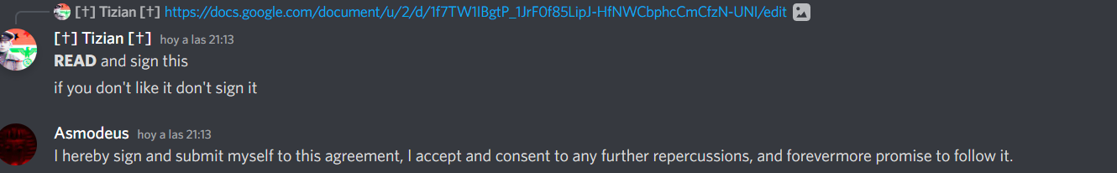



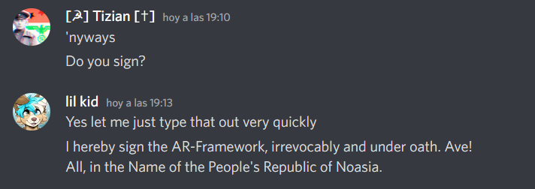







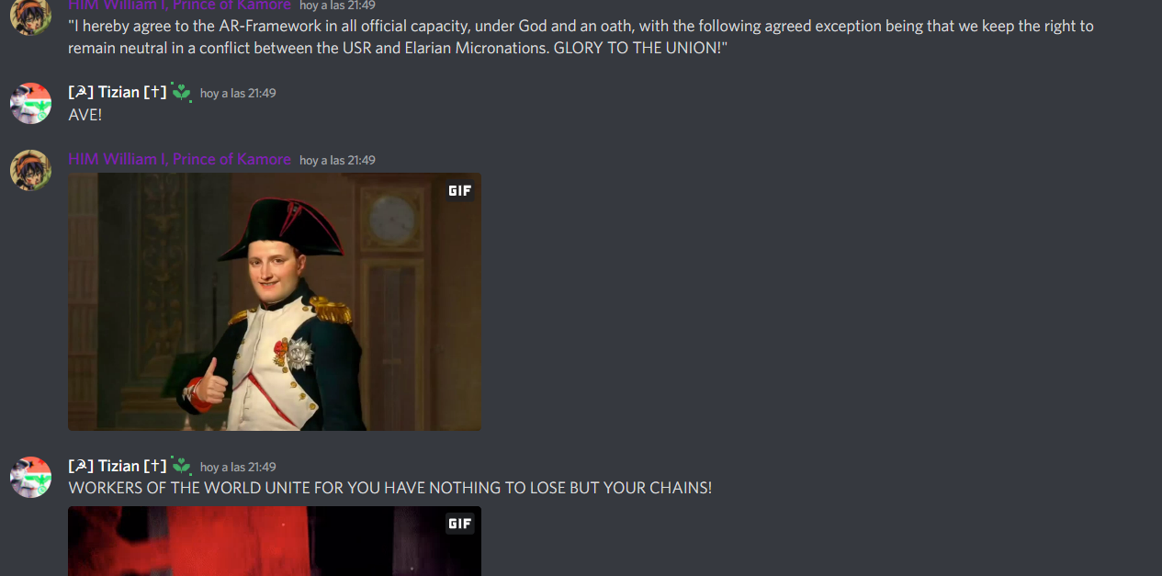  












(Ebenia)

Signed, City-State of Cape.

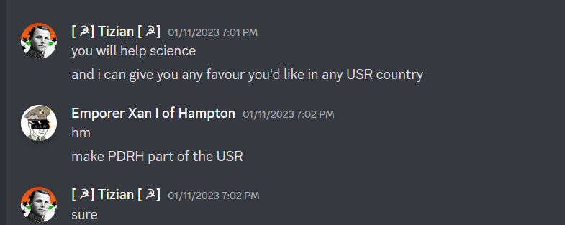



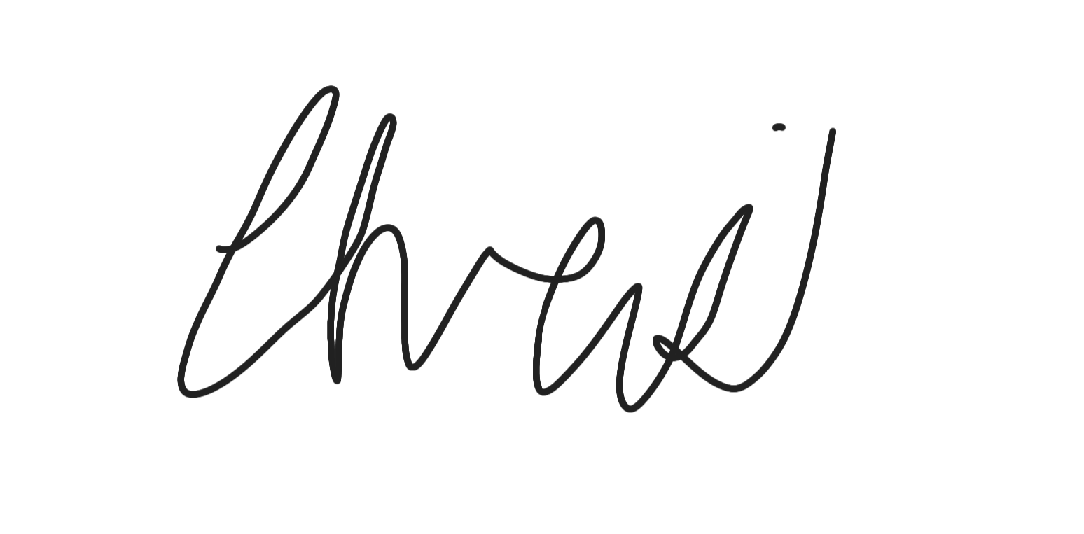(Signature of Christopher of Cristoria)

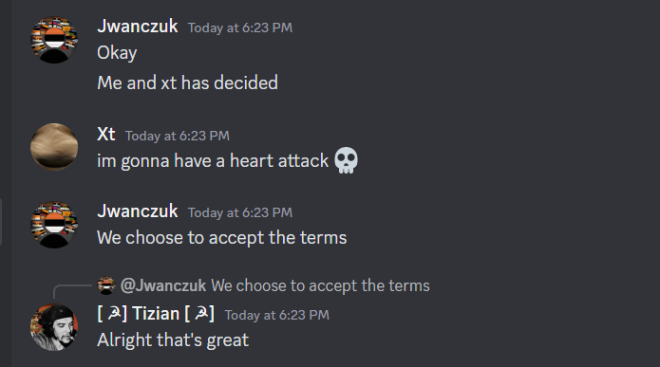

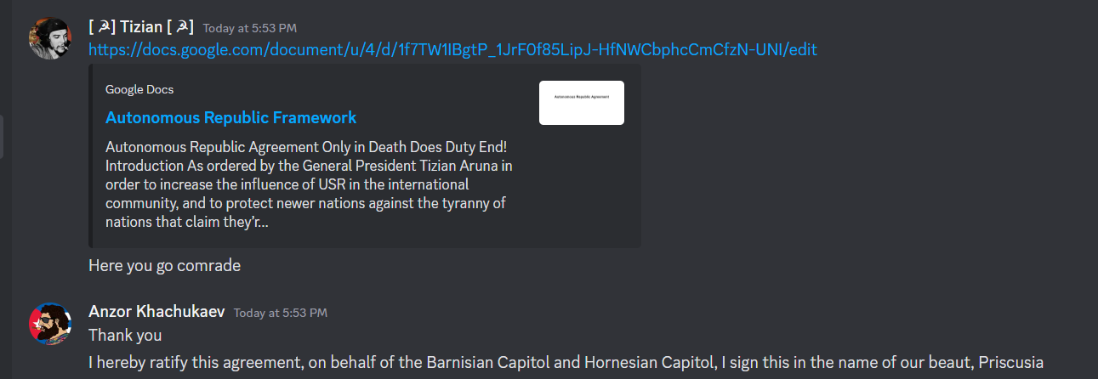

Don't have a Screenshot so Imma just say it. I accept the terms easy